AfanEditor V2.0

Content
Content 1
Menu 2
File 2
Edit 2
View 2
Help 2
Navigation (keys) 2
Icon menu 3
File 3
Select 3
Edit 3
Edit options 3
Transform 3
Move 3
Scale 3
Transform flags 3
Light (unavailable) 4
View options (unavailable) 4
Animation 4
Cameras 4
Undo 4
Engine options 4
Lod states 4
Error trigger 4
Bottom (status) line 4
Edit on the screen 4
Tab Menu 5
Conditions 5
Edit/Action 6
Tab sheets 7
Attack 7
Particle 7
Sound/Anims 8
Light/Wather 8
Editor 8
Animation 10
World Objects 10
Scene 11
Voxel and shadows 12
Tools 14

The afaneditor is designed to create, and edit osr (scene) files for DDDengine. The output is a standard DDDengine object format. So you can edit a full stage, or only a object in the editor.

Menu

File
- New: Make a new empty scene, it is same when you start the editor without reload stage.
Functions are not available in this version.
- Open: Open a osr file to edit, and splines, if there is a alk file, with same name like “name.alk”. Also it can load exclusion world, and static world (not public info). It load the player\player.osr is it is available.
- Save: Save, and overwrite current file.
- Save as: Save scene into new file.
- Save Dynamic objects for DS: Not available.

Edit
Functions are not available in this version.

View
Customize the menus of editor.

Help
Help and about for the afaneditor.

Navigation (keys)
Move on the map:
ALT+cursor - forward, back, and turn
ALT+PgUp/PgDown -up/down
ALT+NUMERIC PLUS/NUMERIC MINUS - zoom the mini-map

LEFT-CTRL+cursor - forward, back, and turn around the selected objects
LEFT-SHIFT+selection - Add selected object to the selection list.

Icon menu

File
open file
save file

Select
Select object on mini-map, click on the start, end the end corners of the selection box..
Select a object on the 3d scene, click on the object on the screen. If you keep down the LEFT-SHIFT button in select, so it will be added to the selection list, otherwise the selection list includes only the selected object. Not working with the transform, so you need switch off the transform mode for it.

Edit
Put selected object to the mini-map, or to the selected helpers, or object on the 3d scene (see Edit on scene).
Clone objects from the selection list.

Edit options
Add random to object put. (not available)
Put object to the voxel surface. (not available)

Transform
You can use the transform with mouse on the screen. (keep down the left, right, or left+right buttons)

Move
Rotate around the center of selected objects.
Rotate around the pivot of objects. (Self rotate)

Scale
Scale by axises.

Transform flags
X axis switch
Y axis switch
Z axis switch

Light (unavailable)

View options (unavailable)

Animation
Play all animations
Pause all animations.
Stop and reset all animations, and movement.

Cameras
Reset camera.
Camera on current spline.
Camera target to the spline from side view. (for platform games) It shows the current texture animation, and you can control that with the cursors, and it will play the animation with the movement.
Switch to the next spline, and switch off after the last spline. The editor draws the current spline with white line into 3d scene.
Exclusion world on/off (reserved)
Static world on/off. (reserved)

Undo
Undo
Redo

Engine options
DX render mode
PSP render mode
Nintendo DS render mode

Lod states
LOD1 (normal)
LOD2 (or destructed state)

Error trigger
When error message writing into the “log\dddengine.log” it is red.

Bottom (status) line
Status: You can work when it is “Ready”.
Coordinates: Camera position in the stage.
Polygon counter: Number of visible polygons when it is activated, otherwise it is 0.

Edit on the screen
Helpres:
- The helpers of current objects (.obj only) are showed in white axies. And you can select them, to move the mouse over it.
You will see the axises of selected objects.
Axis colours:
- normal: white
- selected (the mouse is over of it): green
- red: light
- blue: weather
- purple: camera
Spehres:
- You see the triggersphere of objects.

Tab Menu

Conditions
On first step, set the ambient color.

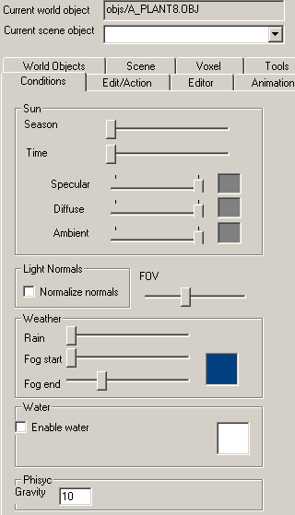

Sun: You can set the stage sun’s properties. It is the light 0, but you can use more on the stage, so you will see the combinations of it. The ambient color set the sky ambient light, and all objects that does not have ambient color. Also you can set the posotion of sun, and the color of the components of light.
Lights Normals: Normalize the normals, so it will modify the specular, and the emission parameters of light. (for test only)
FOV: FOV of camera. (for test only)
Weather: The parameters of weather. But if a stage object has weather, so it will be not used. Note: The weather data is strongly interpolated, so you need wait 10 seconds to the final result, and if the fog start is too near, so you may not see nothing,.
Water: Parameter of weather. You can set the color of it also.
Physic: Physic parameters of stage. (not available)
Voxel: voxel on/off (you need wait some secounds to the initialisation of voxel)

Edit/Action
You can modify the parametres of selected objects. You can select the object on mini-map, or on the 3d scene.
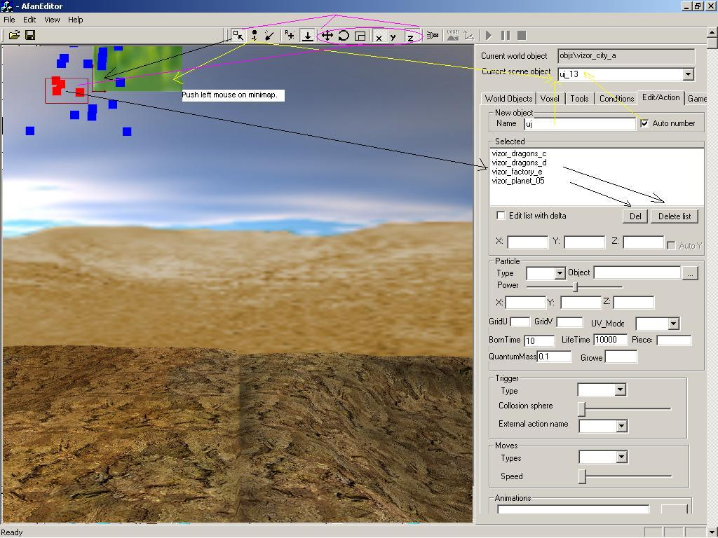
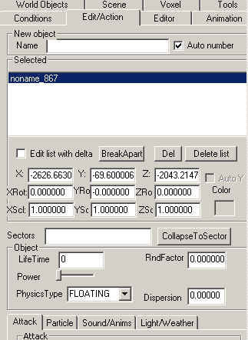
Name: name of the new object, it will be unique by number extension, if it is possible already, for example “tree”, new objects will be: “tree”, “tree_1”, “tree_2”….
Selected: The list of selected object on minimap. You can salace on of them, and modify it’s properties.
Edit list with delta: unavailable.
BreakApart: extract the osr file first level to scece objects. Unavailable.
Del: Delete selected object.
Delete list: Delete all objects from the selected list.
X,Y,Z,Xrot,Yrot,Zrot,Xscal,Yscl,Zscl: modify the matrix of object.
Color: Ambient color of object, if it is not set, so it is from the ambient color of the condition menu.
Sectors: Unavailable.
Objects properties:
LifeTime: if the object will die, or reborn, or it uses a link so you can set the timer for it, otherwise it must be 0. PHYSICS_ROTATE (mini-physics) is active when LifeTime>0.
RndFactor: it is used in all calculaltion, 0 is not random.
Power: Speed of object via object matrix.
Physics Type: mini fast physics programs for objects.
Disperison: poperty of mini-physics. (in sphere, and cone)

Tab sheets
You can choose different parameters for tabs.

Attack
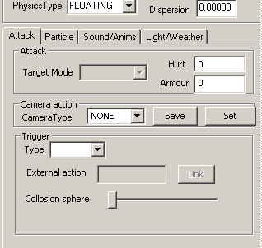
Attack: data for games.
- Target mode: it is available from mini physics.
- Hurt: it decreases the energy of the plater.
- Armour: it is the armour of the current object
Camera action:
- Camera types
- Save: save the matrix of camera of editor to the current object. Easy to set a camera view.
- Set: set the matrix of the camera of editor from the object. Easy to test a camera.
Trigger:
- Type of trigger: unavailable, only sphere
- Collosion sphere: the follow trigger activating in this sphere: camera, mini-physics playanim

Particle
To set a particle, you need select (…) a texture for it.
Delete: delete the particle information from current object.
UV Grid: You can set the type of texture content, for animated textures. So one texture includes the animation frames, by UV animation.
UV_Mode: Type of UV animation.
Anim speed: Speed of texture (UV) animation.
BornTime: short born time make more particle in same time.
LifetTime: time to die. The alpha value calculated by it, so the particle will be invisible on die, and it will be not translucent on born.
Rotation: The rotation speed.
Power: The speed aimed by it’s matrix.
QuantumMass: G factor, in gravity physics (F=G*m1*m2/(r*r))
Size: size.
Growe: size muliplier per frame
Helperpos: move the particle pos to it’s helper. Unavailable.

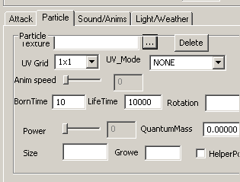

Sound/Anims
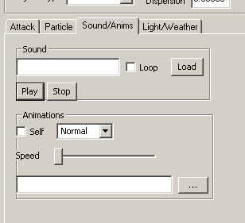
Sound: name of sound file.
Loop: sample loop on/off.
Load: load the sound file.
Play: test the sample.
Stop: stop the current effect.

Animations: not available.
Self: use the objects’s own animation.
Type: animation types.
Speed: Set the speed of animation..
Link: Load a animation for this objects (from different object).

Light/Wather
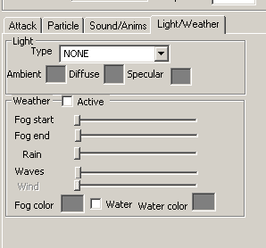
Light: if is has a type, so the light will be active on current objects, otherwise it light object will be deleted.
Light parametres: Ambient, Diffuse, and Specular color.
The light use the object’s matrix, for position, size, and durection.
The point light has position, and scale (from y size).
The diffuse, and specular lights have direction only.

Wehater: if it is active, so the objects get weather parametres, otherwise it will be delete. All components are strongly interpolated, please read about it more in the conditions.
Rain: the power of rain.
Waves: the power of waves on the water surface. It modify the 3d vertexes.

Editor

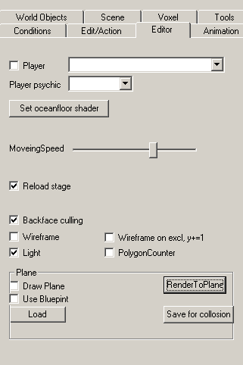
Player: Show player’s object in spline camera mode. More player properties are not available.
Set oceanfloor shader: Set this shader for all objects under Y=0.
Moving speed: speed of control if editor.
Reload stage: If it is checked, so the last edited stage will be loaded automatically.
Backfacel culling: render backface on/off
Wireframe: render wireframe on/off
Light: render sun on/off (not the object lights)
Wireframe on excl, y+=1: not public
PolygonCounter: on/off, the result is in the status line.

Plane parameters:
The plane is a helper surface, that is a map of stage from top view, or from a texture. It is not available.
Draw plane: Draw the helper surface into stage.
Render to plane: Render the top view of stage to the helper surface, and to minimap.
Load: Load the texture of helper surface.
Use blueprint: Minimap texture, or grip.
Save for collosion: Generate 2d collosion map, for optimalizations.

Animation
You can load BMP texture animations, the pink is a colorkey. The animation files need be in same form like this: file_01.bmp, file_02.bmp, …., file_nn.bmp You can test the selected one in the side camera mode.

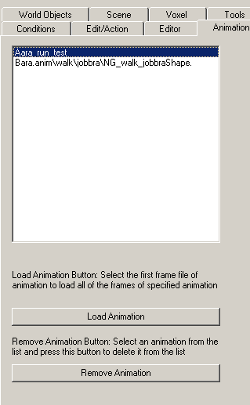

World Objects

You can load object (obj, and osr) here for the editor. If you load a scene, so all used object will be show from the scene. And you can see, and use the objects from the structure of osr. So you can select the current object that you can put to the stage, and it shows in the preview window on left bottom corner.

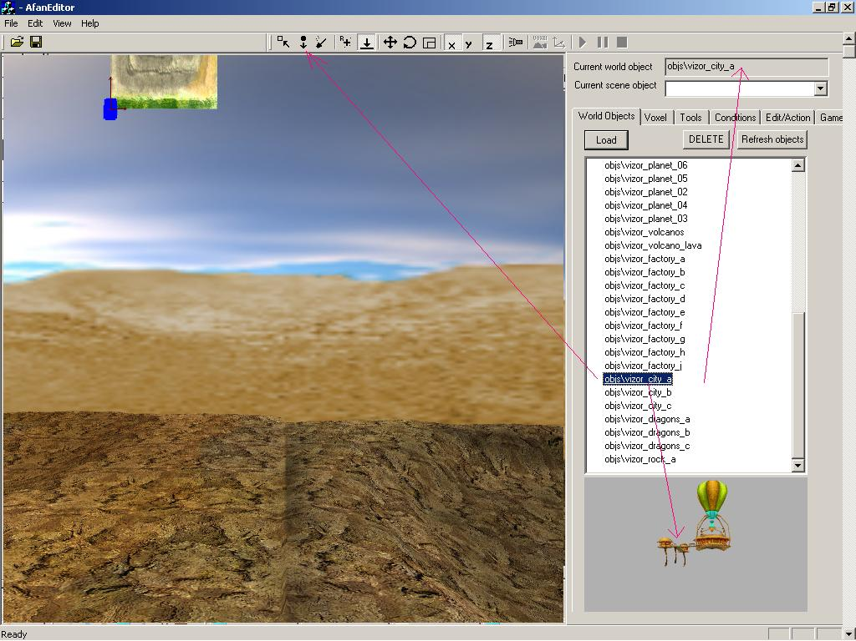

Scene

You can sort the render line for particles, and special alpha objects. Select any item, and use the up/down to move the object in list. The list represents the render line, and the sort of the osr file.

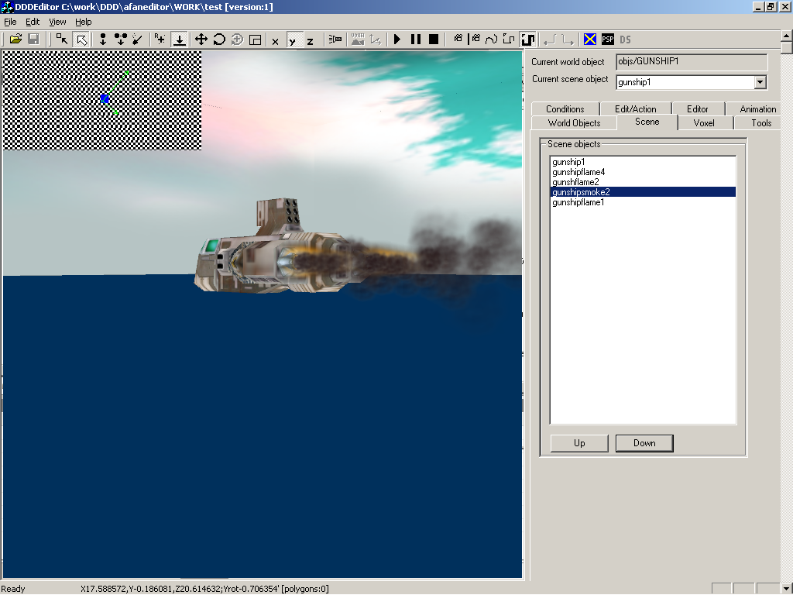

Voxel and shadows

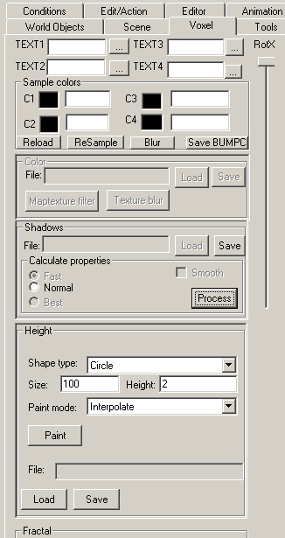
TEXT1-4: select material textures

RotX: rotate camera on X axis (not only in voxel mode)
Sample colors: set material selection colors, see more in voxel documentation.
Reload: reload color data of voxel.
Resample: calculate the material data from color data.
Blur: Blure the material informations.
Save BUMPC: save sample colors data.
Shadow:
Recalculate the shadow:
- Set the calculate properties
- Push the process button.

It will be calculated by session, and the time of the conditions dialog. And you can save it.

Height:
Set the paint shape.
- shape type.
- shape size.
- shape max height.
- paint mode.
- Load height map.
- Save height map.

Paint:
- Increase the height map with left mouse button on mini-map.
- Decrease the height map with right mouse button on mini-map.

Fractal: Fractal ganerator. Unavailabe.

Tools

Generate objects: You can generate object automatically (for woods, and environments) This function is in not public state.

- Name: the base name of new objects, they will get a identify number, like: name_012.obj.
- Set the shape of area.
- Select the object, they will be planted randomly.
- X,Z the delta distance of objects.
- Alpha, Beta: the dispersion of angles
- Szoras: dispersion
Generate: fill the selected area.
Free Hand: put one area on mini-map

Check stage: It is checking the follow problems:
- same position
- particle properties if :
  - borntime<100
  - (lifetime/borntime)>16, more than 16 particles in live from same emitter
  - size>40
- missing objects

All missing object will be selected, after the checking.
